MobileTestingScenario_runTestScenario_Instance3_06-Apr-2016_08-09-05_AM_Staging_Page_Navigation.png

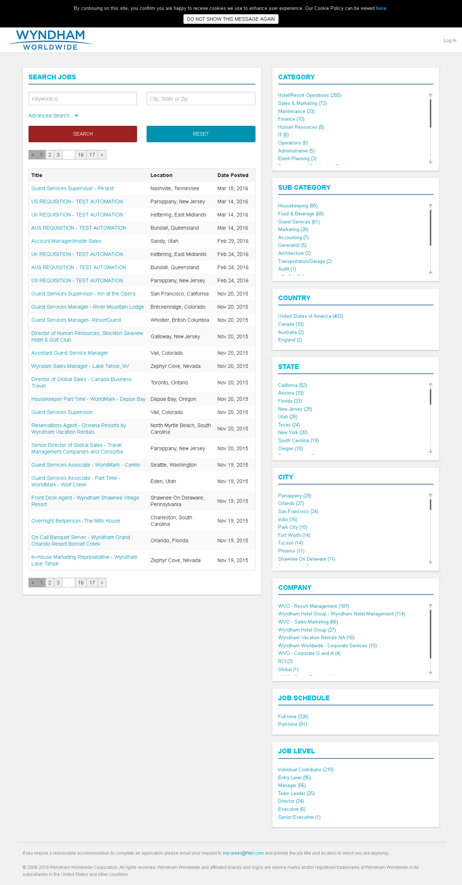

MobileTestingScenario_runTestScenario_Instance3_06-Apr-2016_08-09-35_AM_Create_Account.png

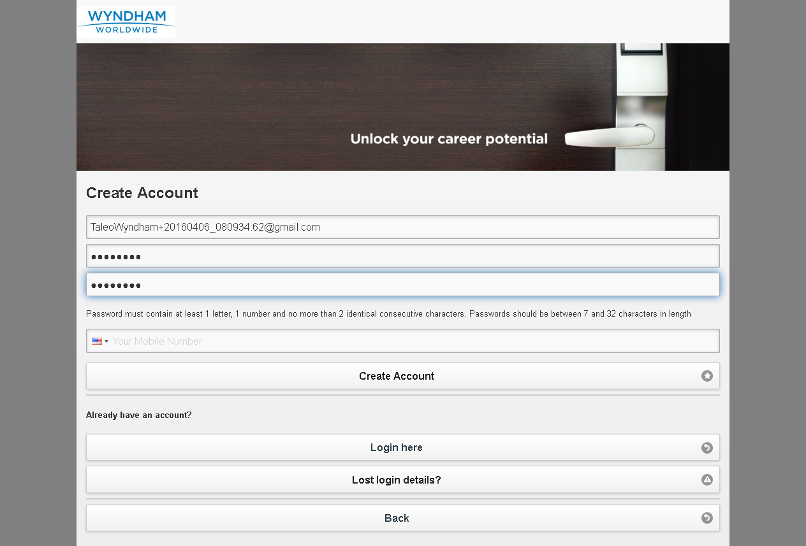

MobileTestingScenario_runTestScenario_Instance3_06-Apr-2016_08-09-51_AM_Continue.png

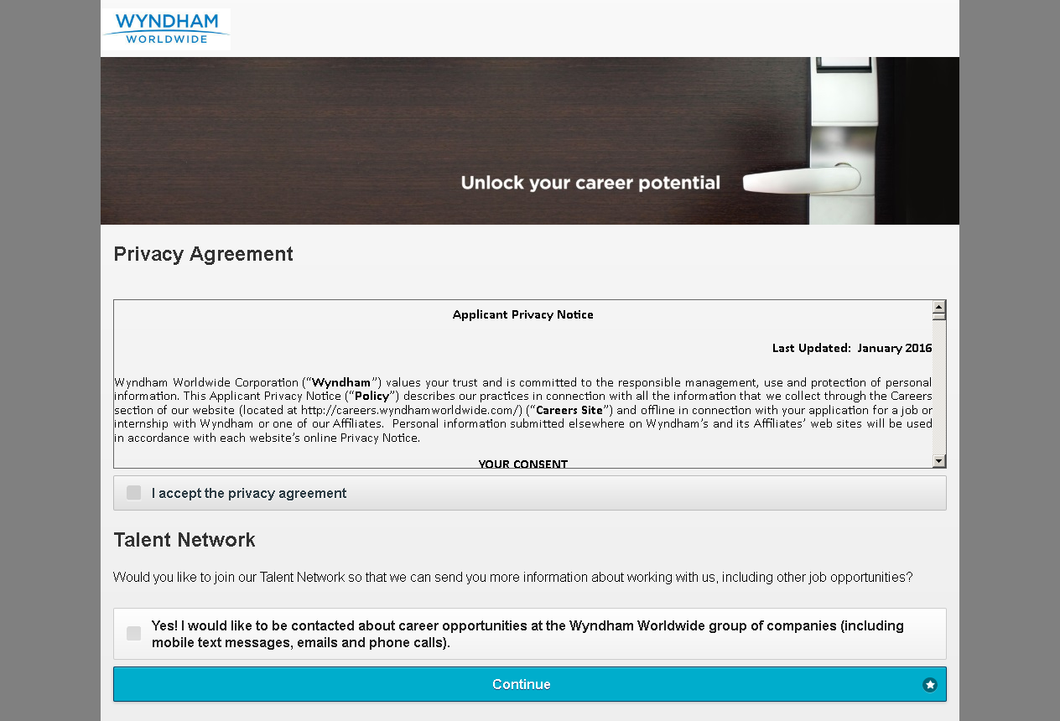

MobileTestingScenario_runTestScenario_Instance3_06-Apr-2016_08-09-51_AM_Create_Account.png



MobileTestingScenario_runTestScenario_Instance3_06-Apr-2016_08-09-55_AM_privacyAgreement.png

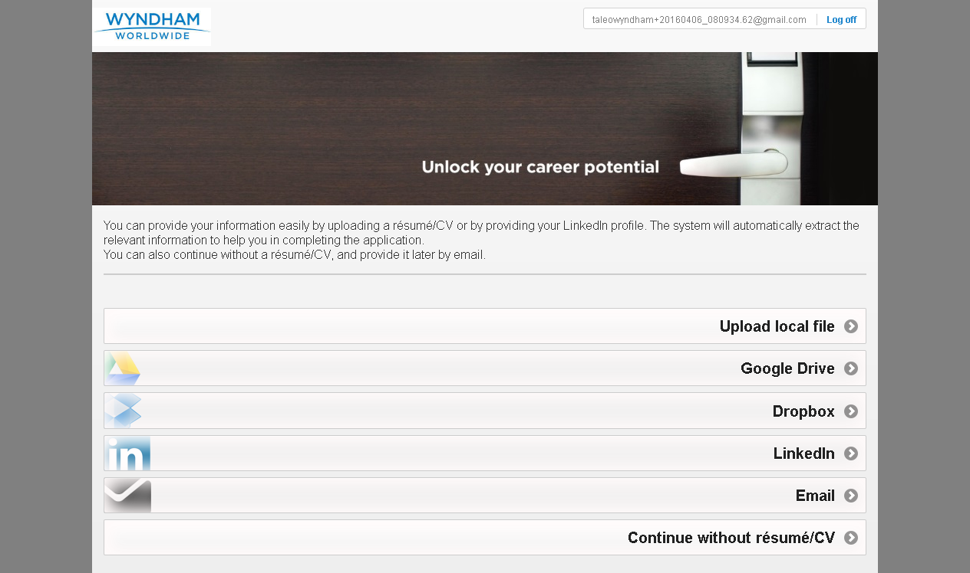

MobileTestingScenario_runTestScenario_Instance3_06-Apr-2016_08-09-57_AM_Resume_Option.png



MobileTestingScenario_runTestScenario_Instance3_06-Apr-2016_08-10-05_AM_Dropbox_Option.png

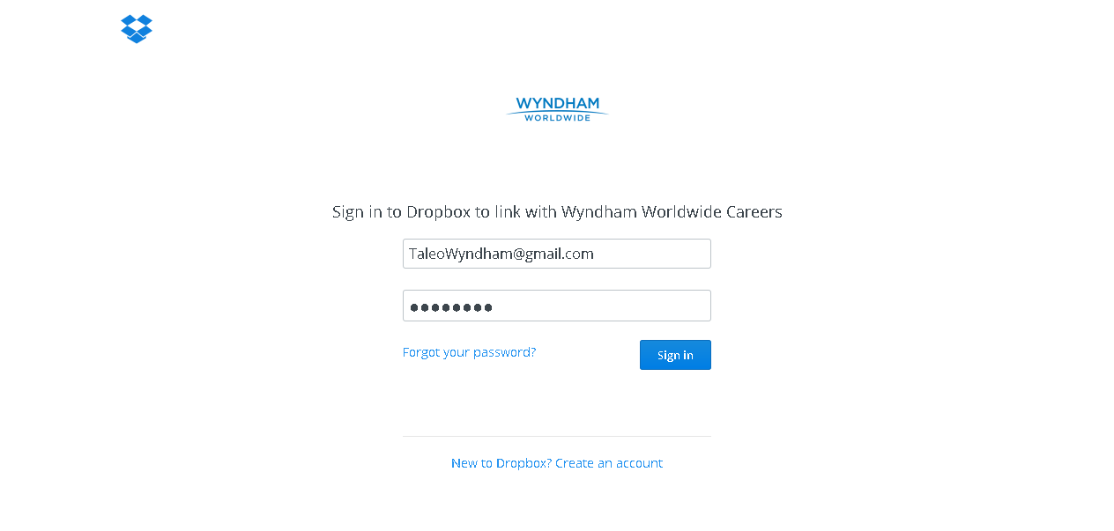

MobileTestingScenario_runTestScenario_Instance3_06-Apr-2016_08-10-19_AM_Dropbox_Option.png

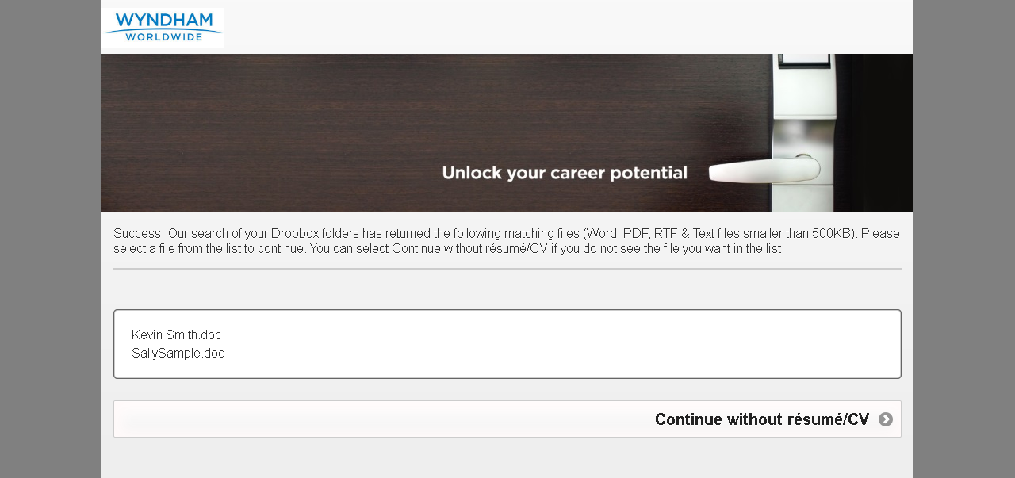

MobileTestingScenario_runTestScenario_Instance3_06-Apr-2016_08-10-24_AM_Dropbox_Option.png

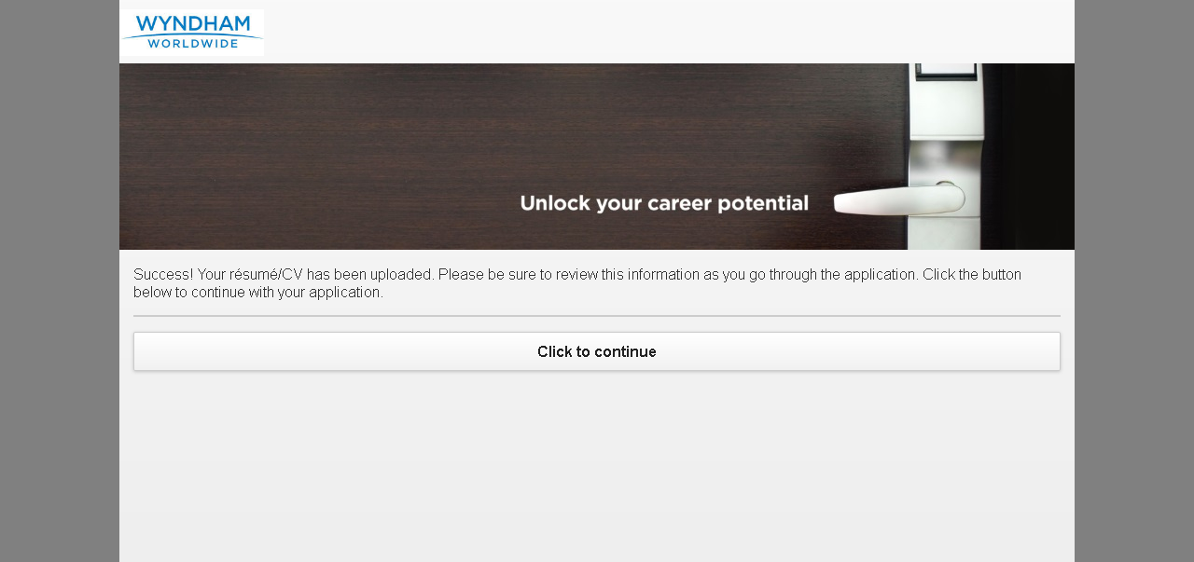

MobileTestingScenario_runTestScenario_Instance3_06-Apr-2016_08-11-07_AM_Tell_us_about_yourself.png

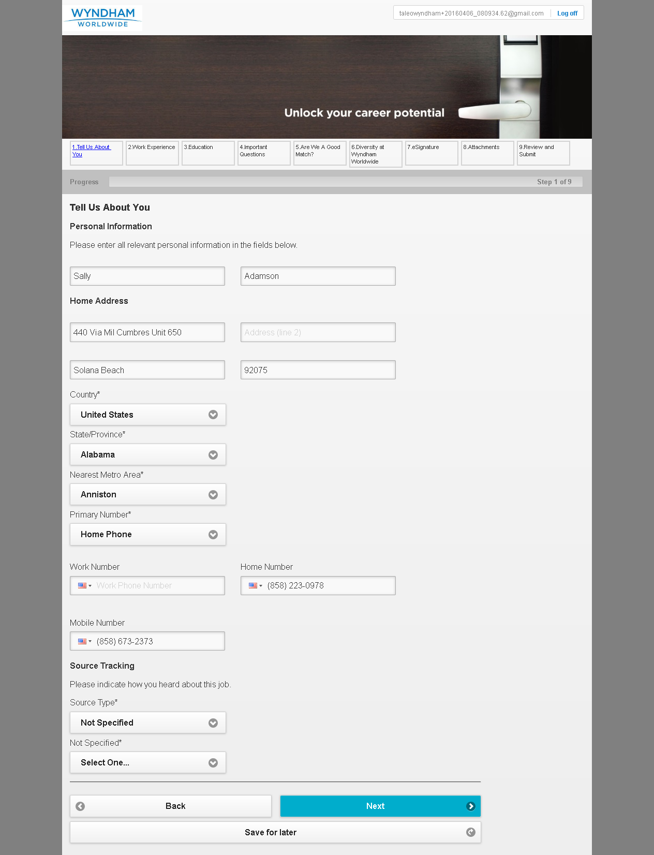

MobileTestingScenario_runTestScenario_Instance3_06-Apr-2016_08-11-18_AM_Tell_us_about_yourself.png

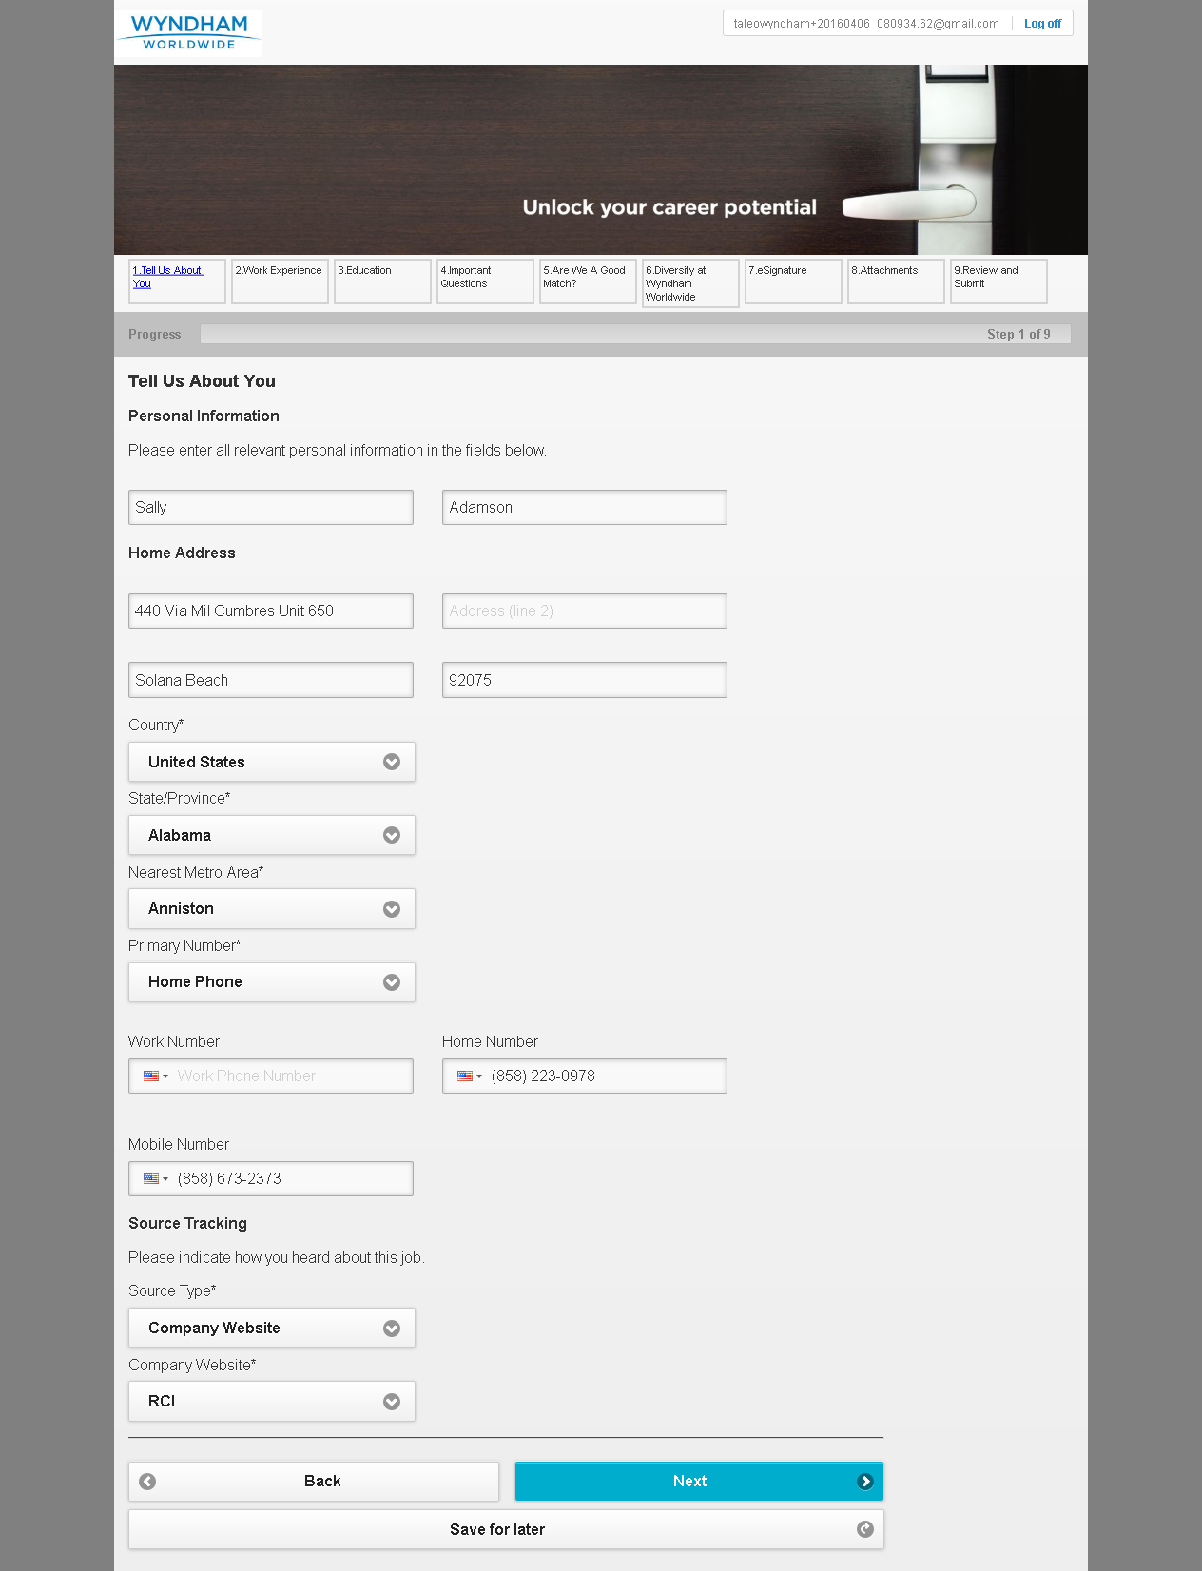

MobileTestingScenario_runTestScenario_Instance3_06-Apr-2016_08-11-30_AM_Work_Experience.png

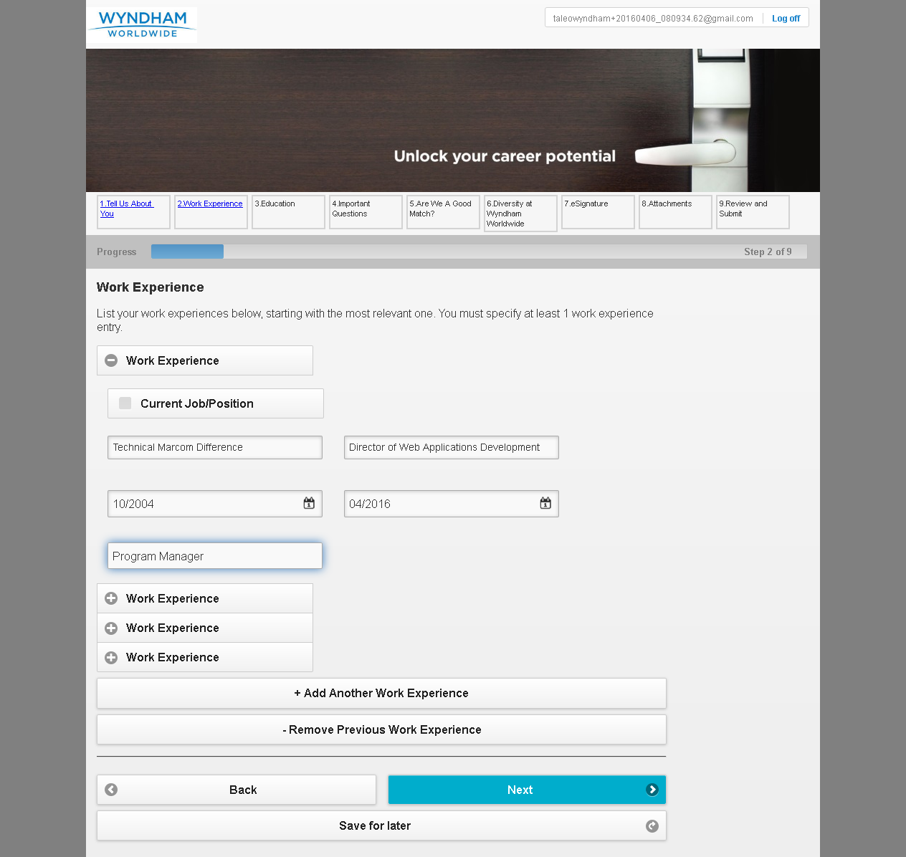

MobileTestingScenario_runTestScenario_Instance3_06-Apr-2016_08-11-47_AM_Education.png

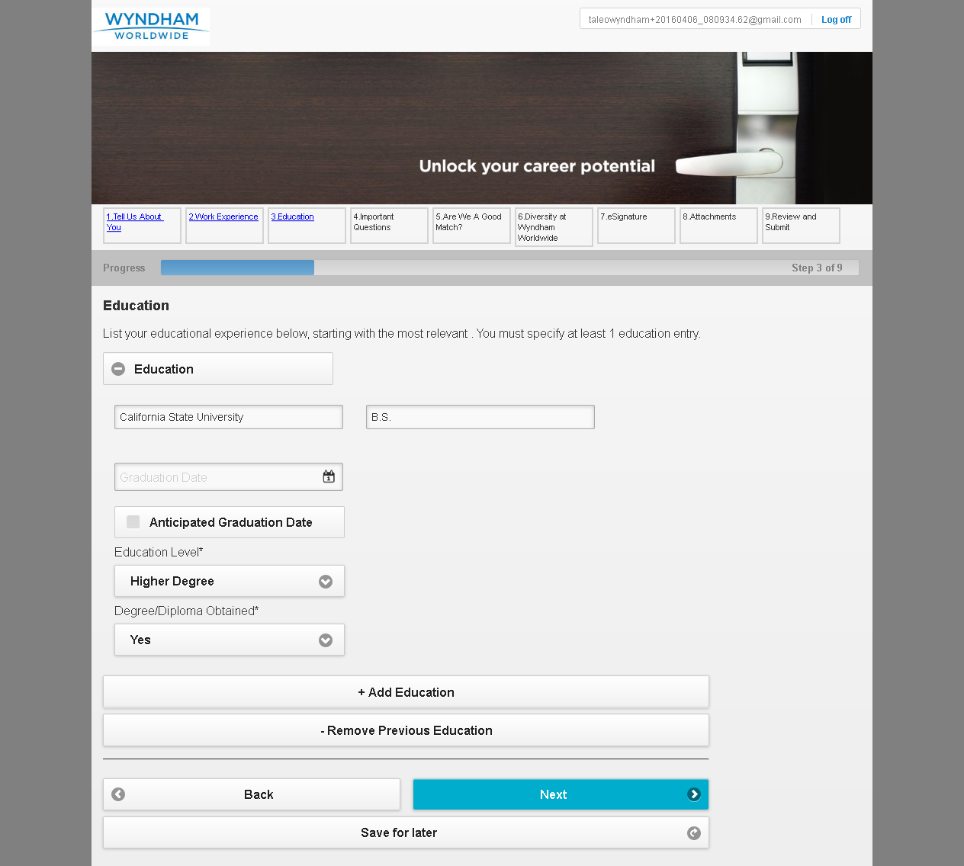

MobileTestingScenario_runTestScenario_Instance3_06-Apr-2016_08-11-54_AM_Questions.png

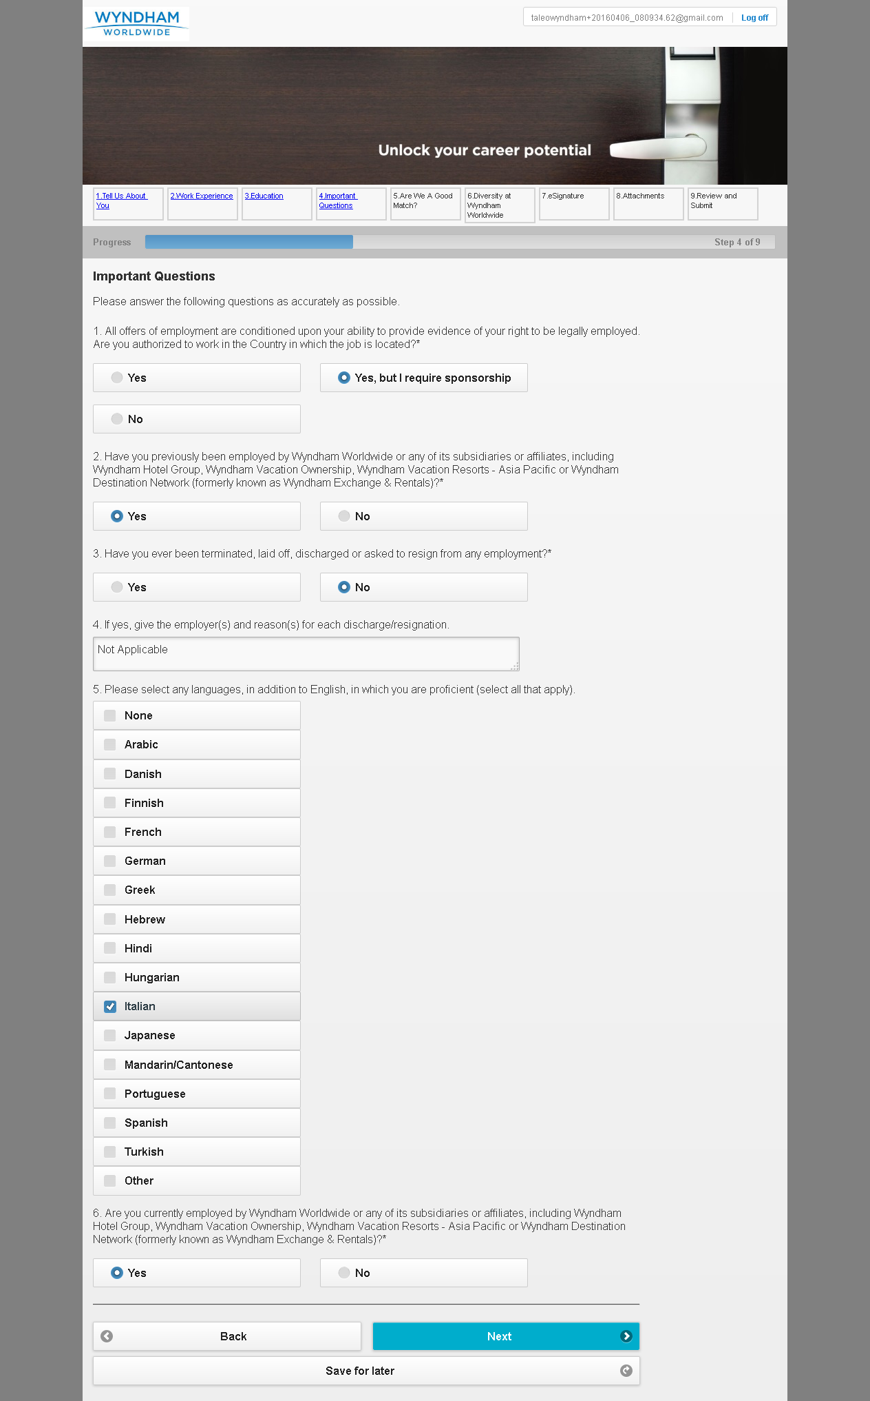

MobileTestingScenario_runTestScenario_Instance3_06-Apr-2016_08-12-02_AM_Are_we_good_Match.png

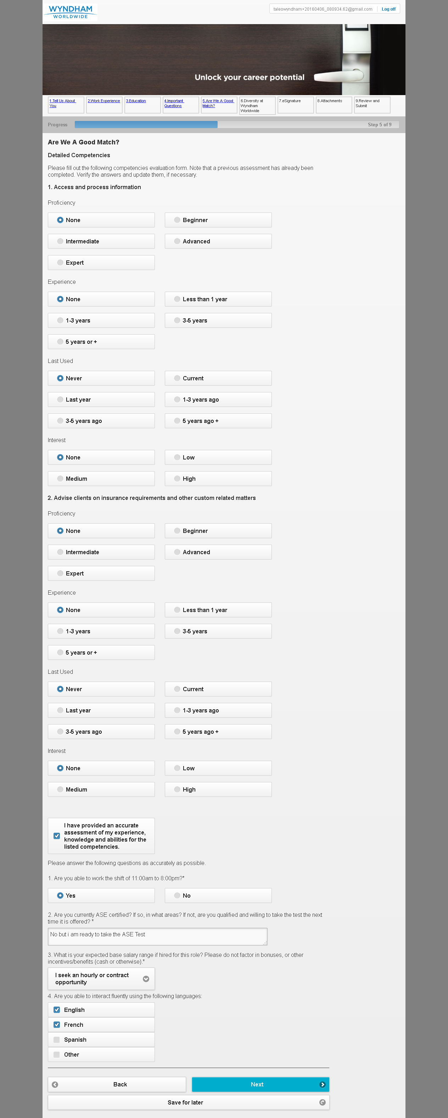

MobileTestingScenario_runTestScenario_Instance3_06-Apr-2016_08-12-26_AM_Diversity.png

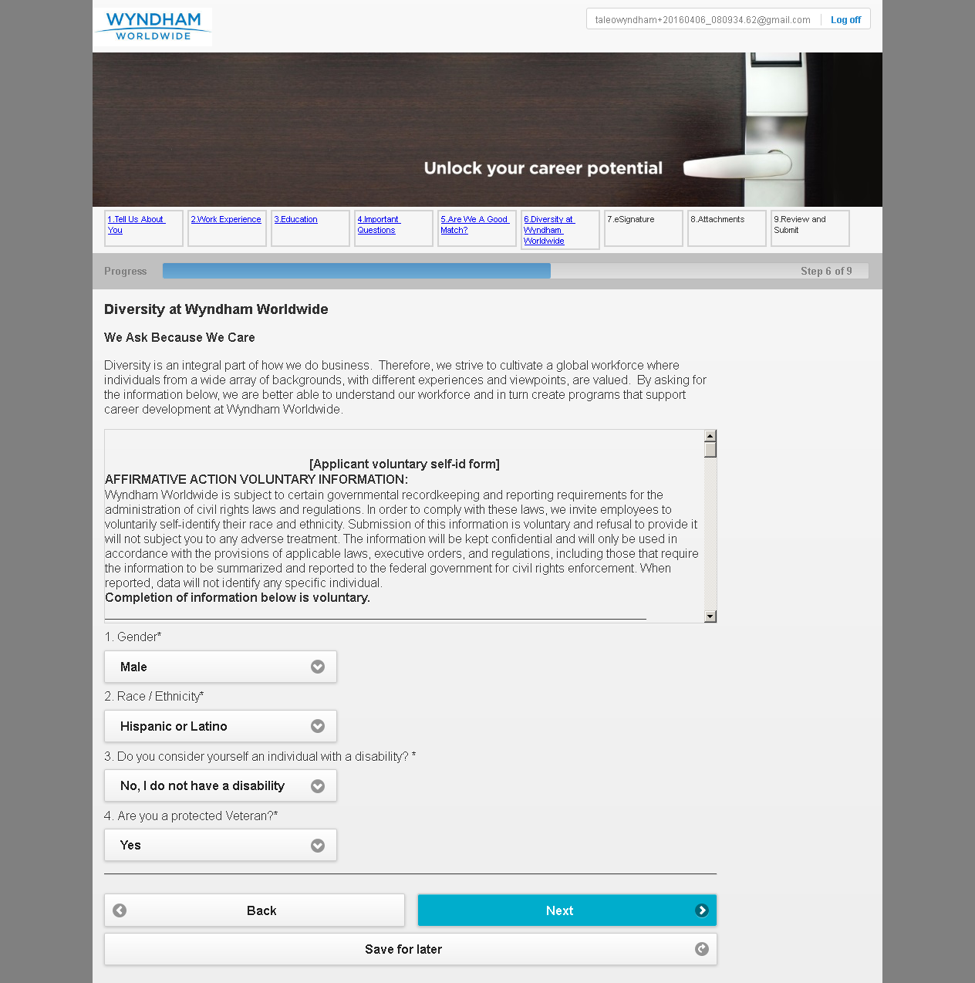

MobileTestingScenario_runTestScenario_Instance3_06-Apr-2016_08-12-34_AM_eSignature.png

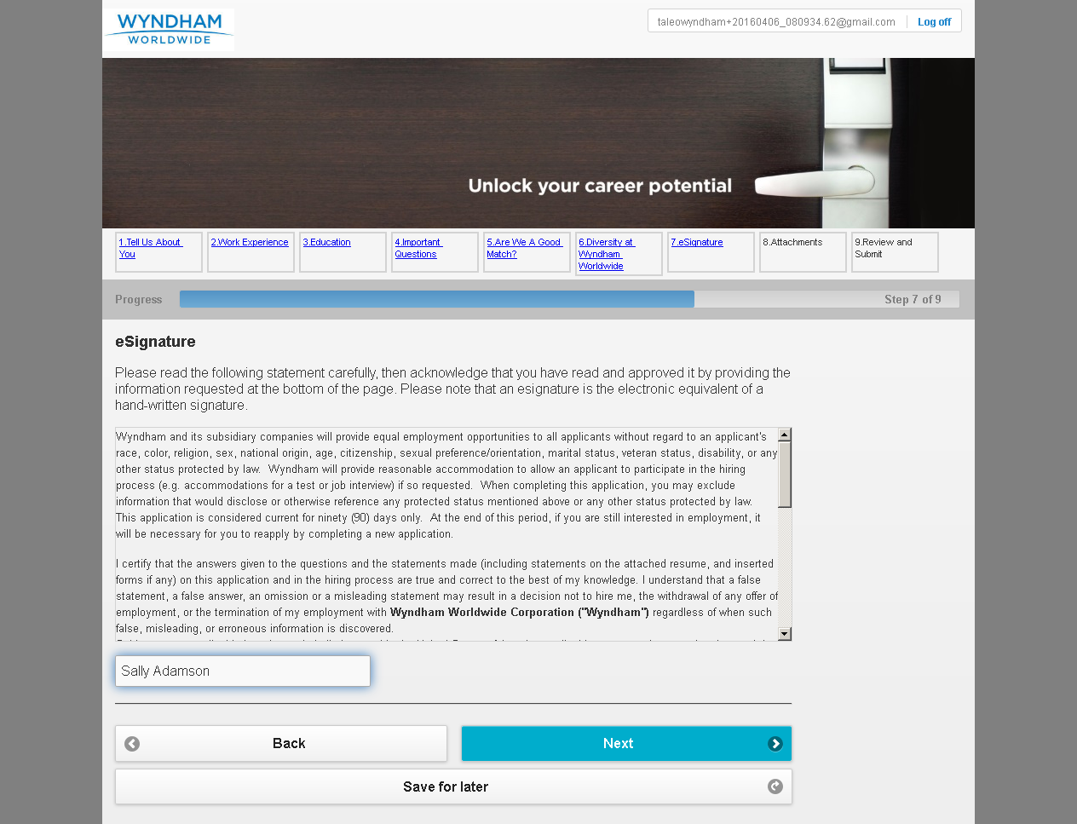

MobileTestingScenario_runTestScenario_Instance3_06-Apr-2016_08-12-41_AM_Attachment.png

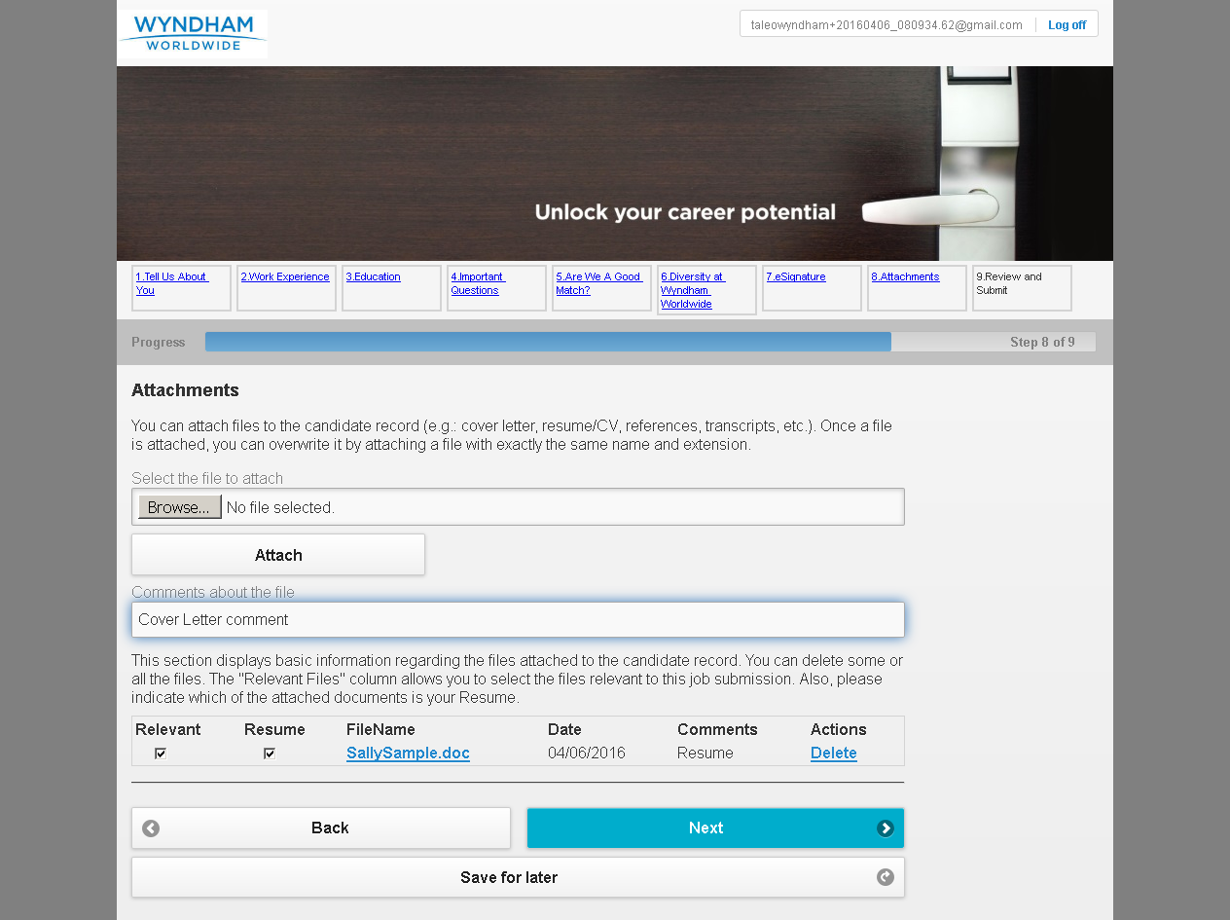

MobileTestingScenario_runTestScenario_Instance3_06-Apr-2016_08-12-52_AM_Review_and_Submit.png

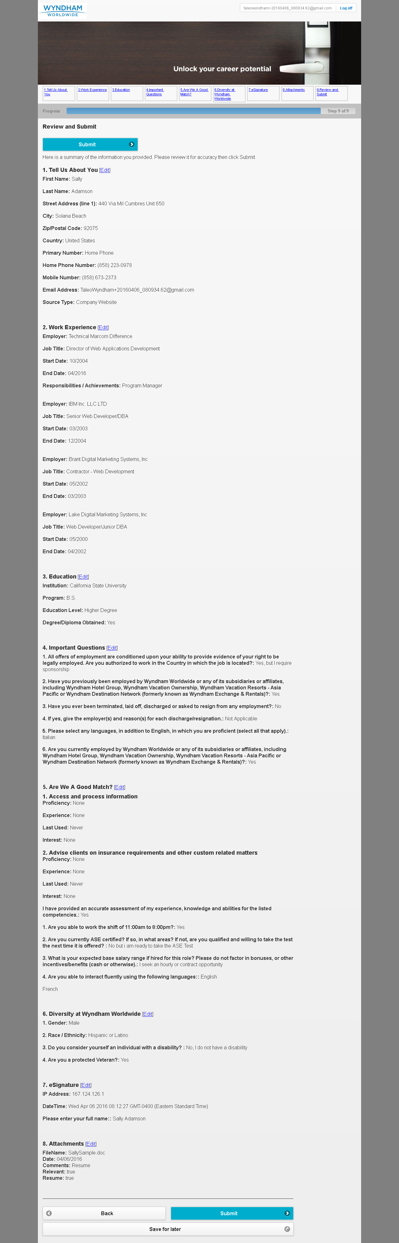

MobileTestingScenario_runTestScenario_Instance3_06-Apr-2016_08-13-03_AM_Application_Completed.png

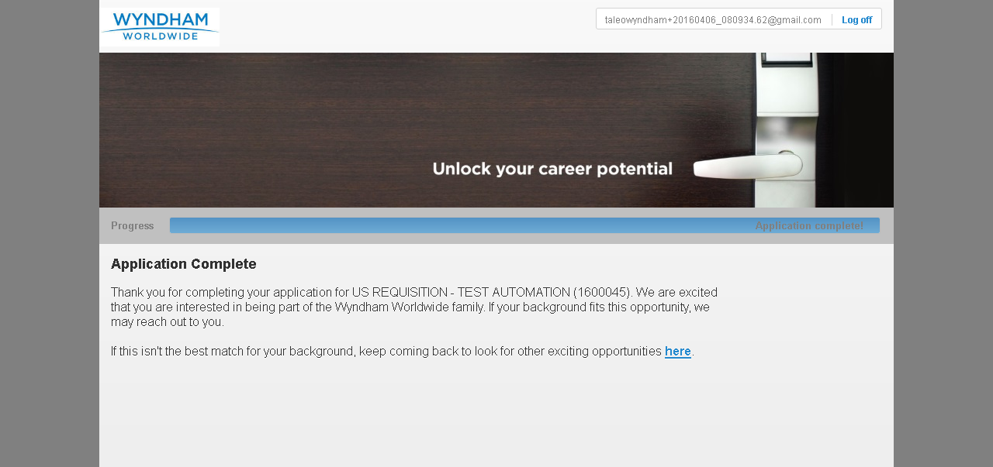

MobileTestingScenario_runTestScenario_Instance3_06-Apr-2016_08-13-18_AM_CRM_Loop_Validation.png

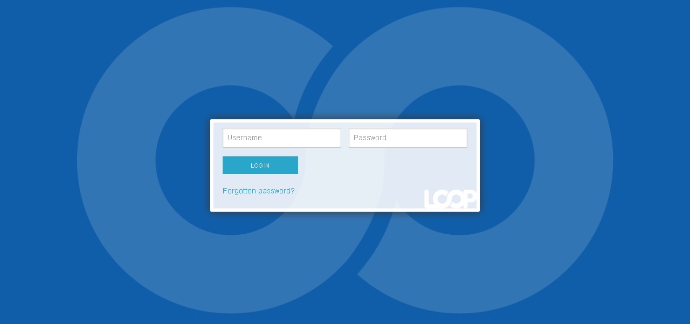

MobileTestingScenario_runTestScenario_Instance3_06-Apr-2016_08-13-26_AM_CRM_Loop_Validation.png

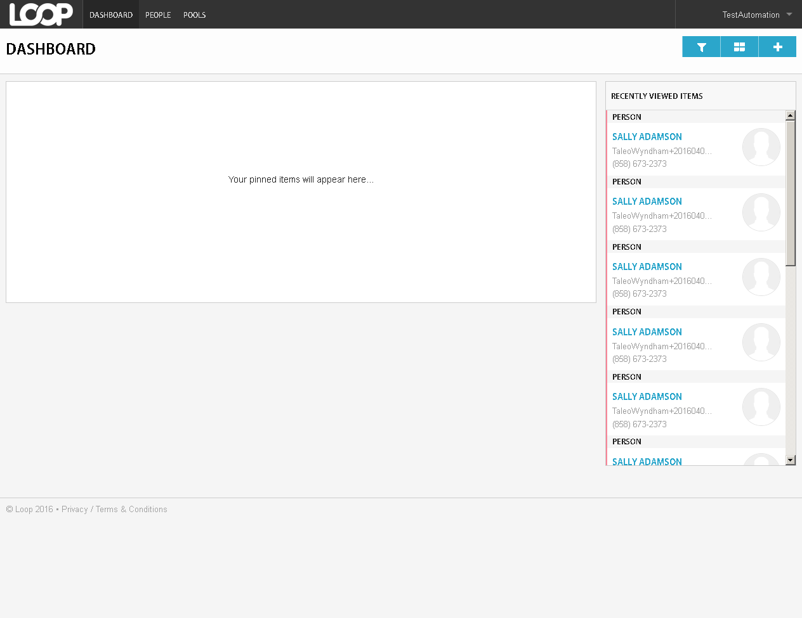

MobileTestingScenario_runTestScenario_Instance3_06-Apr-2016_08-13-47_AM_CRM_Loop_Validation.png

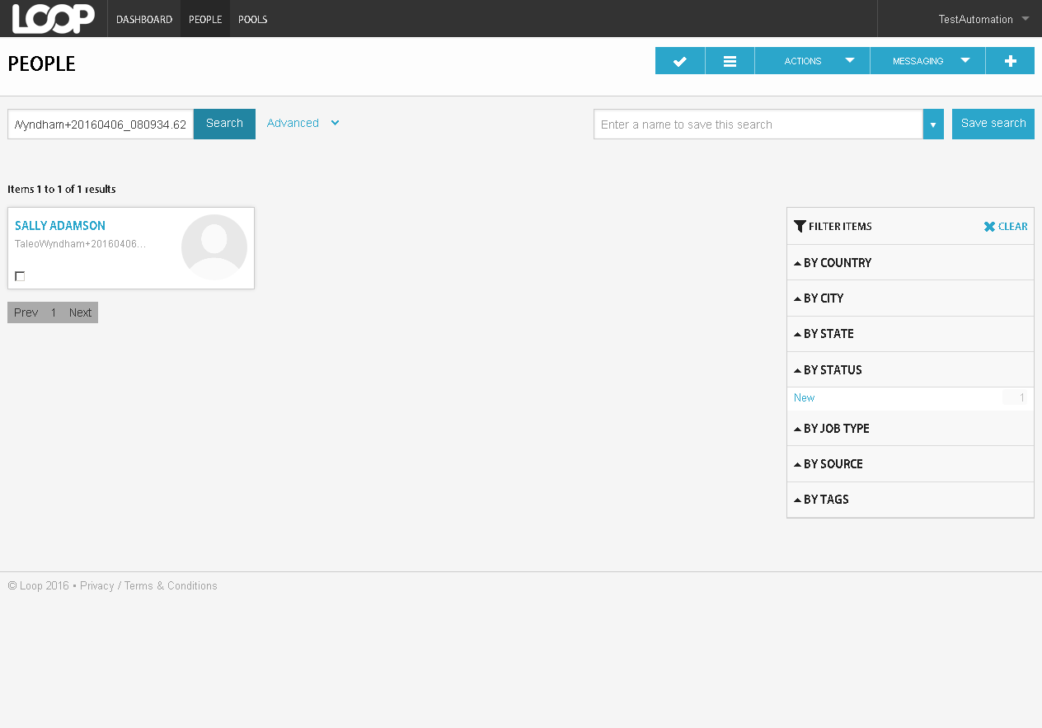

MobileTestingScenario_runTestScenario_Instance3_06-Apr-2016_08-13-52_AM_CRM_Loop_Validation.png

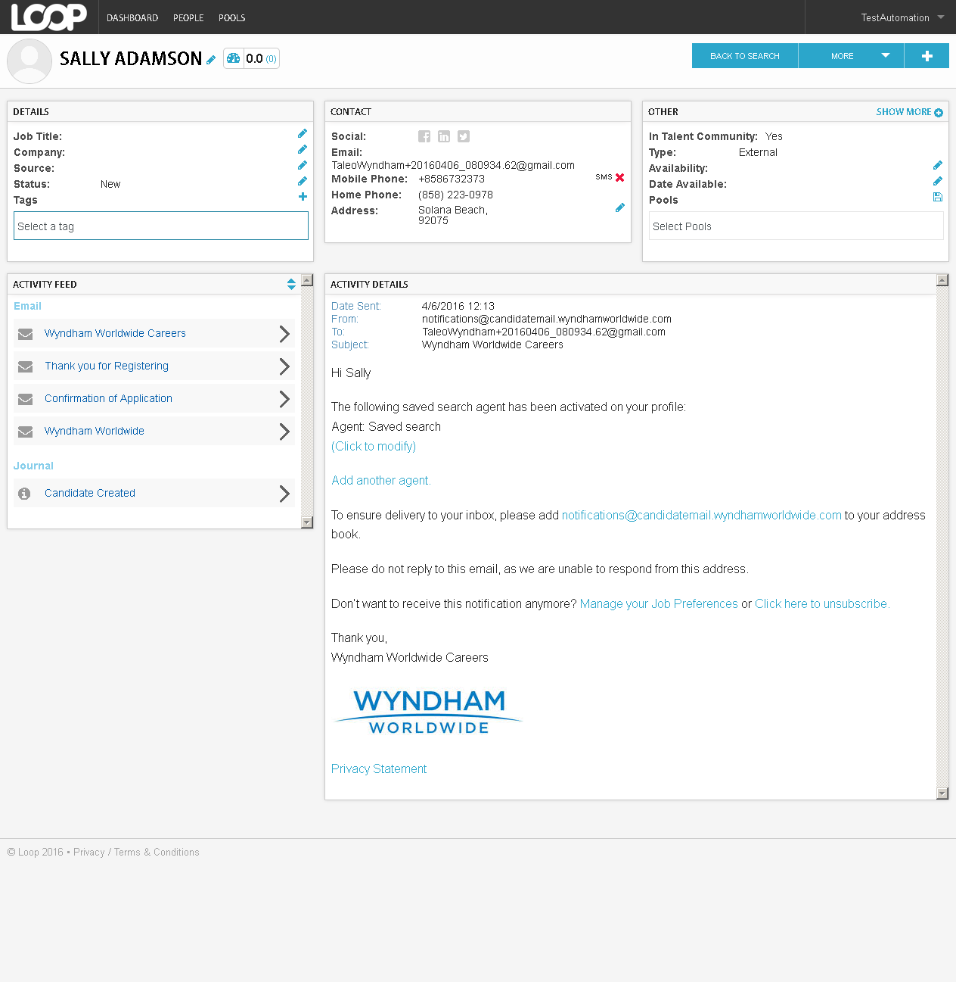

MobileTestingScenario_runTestScenario_Instance3_06-Apr-2016_08-13-58_AM_CRM_Loop_Validation.png



MobileTestingScenario_runTestScenario_Instance3_06-Apr-2016_08-14-04_AM_Login_Page.png



MobileTestingScenario_runTestScenario_Instance3_06-Apr-2016_08-14-26_AM_Candidate_Search_Page.png

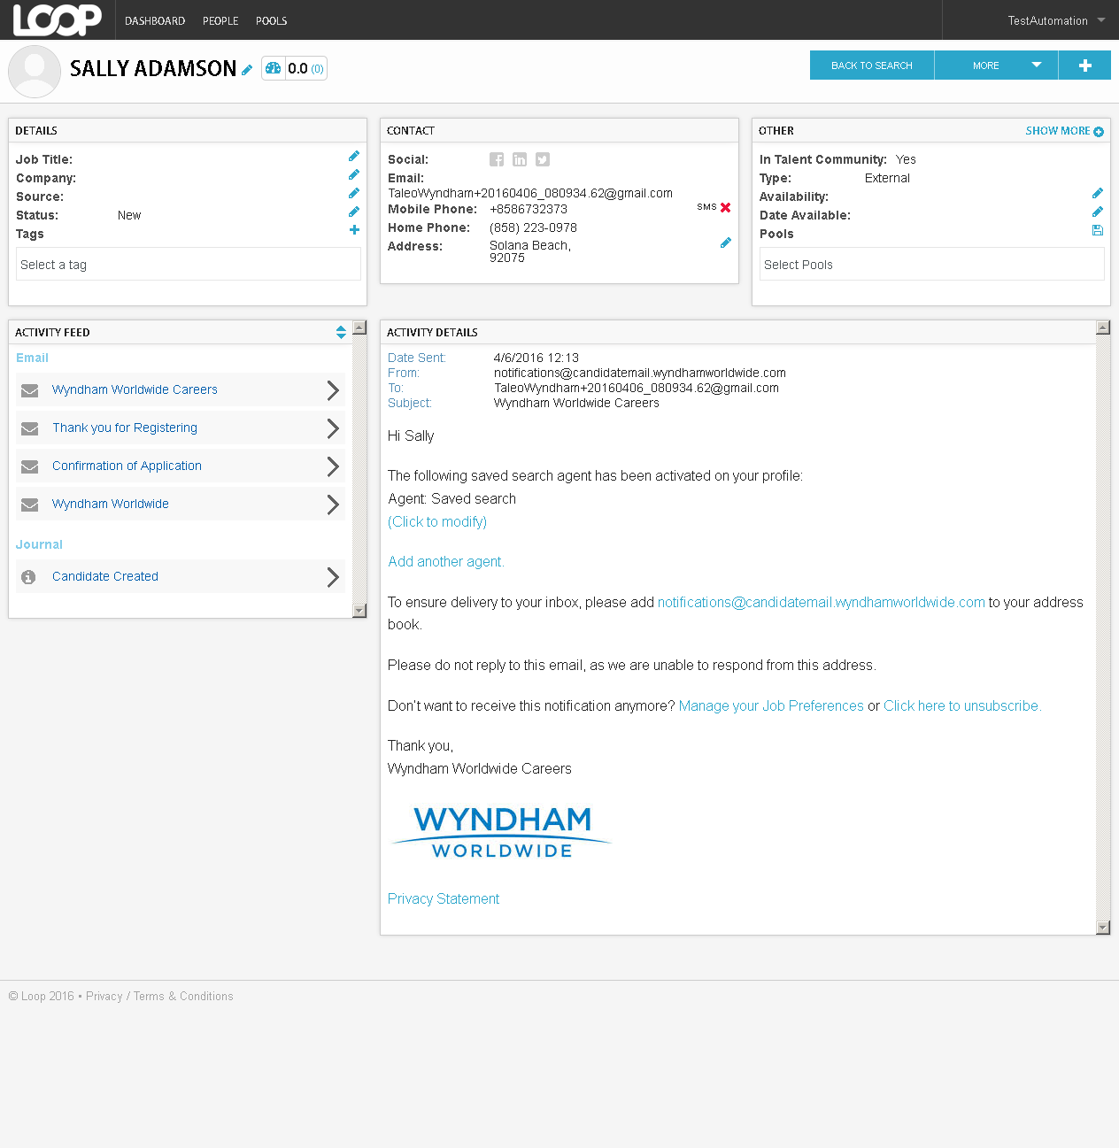

MobileTestingScenario_runTestScenario_Instance3_06-Apr-2016_08-14-47_AM_Candidate_Home.png



MobileTestingScenario_runTestScenario_Instance3_06-Apr-2016_08-15-17_AM_Attachhments.png



MobileTestingScenario_runTestScenario_Instance3_06-Apr-2016_08-15-38_AM_PDF_Contents.png

